

JMeter Performance Test Plan
for Incentivio

Revision History

Revision | Author | Date | Description
V1.0 | Vikum Warnakula | 11/08/2020 | Jmeter Test Plan

Note:
These documents are strictly for specific Aeturnum/client use only. They shall not be shared with an external party other than the client concerned. These documents should always be kept securely and employees shall use reasonable care protecting these documents from unauthorized use or disclosure to a third party. This category also covers client intellectual property where Aeturnum has a non-disclosure agreement with the client.

Table of Contents
1. Introduction to Jmeter 3
1.1 What is Jmeter? 3
1.2 JMeter Features 4
1.3 JMeter Installation 4
2. Incentivio Test Plan 5
2.1 Project Structure 5
2.2 Guidelines 5
2.3 Perform Load Test 5
2.4 Performance Metrices 6
2.5 Sample Results 6

Introduction to JMeter

What is JMeter?

JMeter is a software that can perform load test, performance-oriented business functional test, regression test, etc., on protocols and technologies.

JMeter is a java desktop application with a graphical interface that uses the Swing graphical API. It can therefore run on any environment / workstation that accepts a java virtual machine for example – Windows, Linux, Mac etc.

The protocols supported by JMeter are –

Web − HTTP, HTTPS sites 'web 1.0' web 2.0 ajax, flexandflex − ws – amf

Web Services − SOAP / XML-RPC

Database via JDBC drivers

Directory – LDAP

Messaging Oriented service via JMS

Service − POP3, IMAP, SMTP

FTP Service

JMeter Features
- Being an open source software, it is freely available.
- It has a simple and intuitive GUI.
- JMeter can conduct load and performance test for many different server types − Web - HTTP,HTTPS, SOAP, Database via JDBC, LDAP, JMS, Mail - POP3, etc.
- It is a platform-independent tool. On Linux/Unix, JMeter can be invoked by clicking on JMeter
shell script. On Windows, it can be invoked by starting the jmeter.bat file.
- JMeter store its test plans in XML format. This means you can generate a test plan using a text editor.
- Its full multi-threading framework allows concurrent sampling by many threads and
simultaneous sampling of different functions by separate thread groups.
- It is highly extensible.
- It can also be used to perform automated and functional testing of the applications.

JMeter Installation

Verify java Installation
First of all, verify whether you have Java installed in your system. Open your console and execute
one of the following java commands based on the operating system you are working on.
OS | Task | Command
Windows | Open Command Console | c:\> java -version
Linux | Open Command Terminal | $ java -version
Mac | Open Terminal Machine | ~ joseph$ java -version

Set Java Environment

Download JMeter
Download the latest version of JMeter from http://jmeter.apache.org/download_jmeter.cgi. copy it into C:\>JMeter folder.

Run JMeter
After downloading JMeter, go to the bin directory. Directory : Apache JMeter\apache-jmeter-5.3\bin
Click on related file.

OS | Output
Windows | jmeter.bat
Linux | jmeter.sh
Mac | jmeter.sh

Incentivio Test Plan

Project Structure
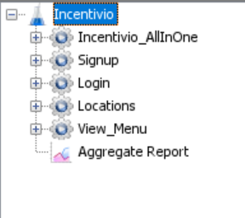
Project consists of several thread groups in which one thread group (Incentivio_AllInOne) is a request flow that one customer may proceed. All other thread groups are allocated for individual end points.

Guidelines
- Dummy email address has been created for testplan use. (aetincentivioperformance@gmail.com)
Same email is used to create users for signup endpoint by adding “+” mark end of the username
Ex: aetincentivioperformance+1000000@gmail.com
- “Counter” Config element is used to produce new email addresses for each iteration.
- “CSV Data Set Config” is used to generate test data from a CSV file.
- “Random Variable” Config element is used to randomize email address input for login endpoint.
- Listeners specially “View Results Tree” and Debug Samplers should be disabled when running load test since they consume considerable weight of time.

Perform Load Test

Setup a Performance environment which has same hardware and Release version as Production environment or scaled down to production environment.
- Open .jmx project from JMeter.
- Click on Test Plan and change {ServerIP} variable value to relevant Performance environment IP.
- Define a range for email address and run Signup request. (Please change counter values). These generated email addresses are used for login endpoint.
- ${__Random(0,10, MYVAR)}function has been used to generate random email addresses for Signup endpoints. Change function min max values according to the project requirement.
- Run some sample requests and check whether environment is working fine.
- Run thread groups parallelly or individually.
- Monitor real time “Aggregate Report” Results.

Performance Metrices
- Percentiles
A percentile is a very useful performance testing metric that gives a measure under which a percentage of the sample is found. For example, the 90th percentile (abbreviated as p90) indicates that 90% of the sample is below that value and the rest of the values (that is, the other 10%) are above it.

- Average
To calculate the average, simply add up all the values of the samples and then divide that number by the number of samples. Let’s say I do this and my resulting average is 3 seconds. The problem with this is that, at face value, it gives you a false sense that all response times are about three seconds, some a little more and some a little less, but that might not be the case.

- Throughput
indicates the number of transactions per second an application can handle, the amount of transactions produced over time during a test.

- Medians
Medians are often confused with average. Unlike average where we take from the rich and give to the poor, the median examines the amount that the middle member participant has. To determine the median, line up the members from minimum to maximum, mark the member in the middle and see what his amount is.

Sample Results

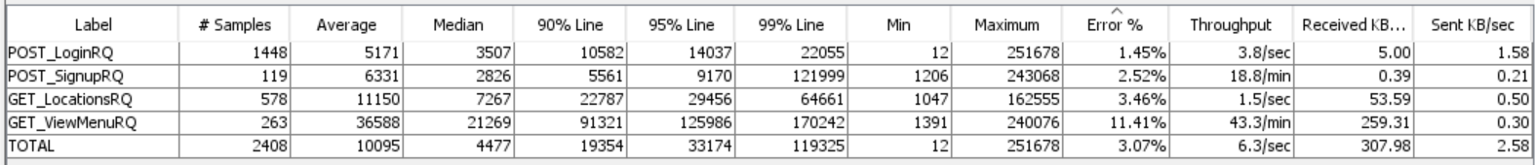

Note: Results given above were run for dev environment.

